**___________________________**

**MOVIE TICKET BOOKING SYSTEM**

**___________________________**

**TABLE OF CONTENTS**

|  |  |  |
| --- | --- | --- |
| Chapter | Title | Page |
| 1 | Abstract | 4 |
| 2 | Introduction | 5 |
|  | 1. Project Objective | 5 |
|  | 1. Project Overview | 5 |
|  | 1. Project Scope | 6 |
| 3 | System Analysis | 7 |
|  | 1. Non Functional Requirements | 7 |
|  | 1. Functional Requirements | 8 |
| 4 | System Design | 11 |
|  | 1. Input Design | 11 |
|  | 1. Output Design | 12 |
| 5 | Database | 13 |
| 6 | System Tools | 14 |
|  | 1. Front End | 14 |
|  | 1. Back End | 14 |
| 7 | Tables | 15-16 |
| 8 | Diagrams | 17 |
|  | 1. ER Diagram | 17 |
|  | 1. User Case Diagram | 17 |
|  | 1. Data Flow Diagram | 18 |
| 9 | Form Designing | 19-23 |
| 10 | Form Coding’s | 24-27 |
| 11 | Conclusion | 28 |
| 12 | References | 29 |

**___________________________**

**ABSTRACT**

**___________________________**

**ABSTRACT**

This project is a web based online movie ticket booking for an existing theatre. The project objective is to book the ticket uploaded by the authorities online.

This project is an attempt to provide the advantages of booking tickets online to users in a particular theatre. It helps getting ticket details and information about movie through text message in their mobile anywhere through internet. Thus the users will get the benefit of online booking and they do not have to stand in a queue for the tickets. This system can be implemented to any movie theatre in the locality.

The movie details are uploaded by the authorities of the theatre for.

**___________________________**

**INTRODUCTION**

**___________________________**

**INTRODUCTION**

This project is a web based online movie ticket booking for an existing theatre. The project objective is to book the ticket uploaded by the authorities online.

This project is an attempt to provide the advantages of booking tickets online to users in a particular theatre. It helps getting ticket details and information about movie through text message in their mobile anywhere through internet. Thus the users will get the benefit of online booking and they do not have to stand in a queue for the tickets. This system can be implemented to any movie theatre in the locality.

The movie details are uploaded by the authorities of the theatre for.

* 1. **PROJECT OBJECTIVE:**
* To make movie ticket booking process easy through online.
* User should not need to stand in a queue for booking their movie tickets.
* Authorities can be able to easily upload the details of movies.
* User will get their ticket details through message.

**1.2 PROJECT OVERVIEW:**

The central concept of this web application is to allow the users to book the tickets of a movie which is running in the particular theatre.

The authorized staff can upload, delete and edit the movie details with the necessary documents. No others unauthorized staff can make any changes to the upload section of the website. Each authorized staff have to make login in to this application with their Username and Password to upload or change the movie details.

**1.3** **PROJECT SCOPE:**

This system can be implemented for any particular movie theatre so that they can upload movie details for the users.

It allows all users to have access website after login so that they can book tickets from anywhere and from any device. No one has to go to specific location to book the tickets. It make easy to upload movie details for theatre staff and to view the seats left for user from any location and from any device. Since the application is available in the online web it is easily accessible and always available.

**___________________________**

**SYSTEM ANALYSIS**

**___________________________**

**SYSTEM ANALYSIS**

System analysis is the process of gathering and interpreting facts, diagnosing problems and using the information to recommend improvements on the system. System analysis is a problem solving activity that requires intensive communication between the system users and system developers.

System analysis or study is an important phase of any system development process. The system is viewed as a whole, the inputs are identified and the system is subjected to close study to identify the problem areas. The solutions are given as a proposal. The proposal is reviewed on user request and suitable changes are made. This loop ends as soon as the user is satisfied with the proposal.

**FUNCTIONAL REQUIREMENTS**

**FR.1: ADDING MOVIES DETAILS**

* R.1.1: Enter the movies name
* **Input**: Enter the movies name
* **Output**: Movies name gets added in application and stored in database
* R.1.2: Enter the movies genre
* **Input**: Enter the movies genre
* **Output**: Movies genre gets added in application and stored in database
* R.1.3: Enter the movies actors
* **Input**: Enter the movies actors
* **Output**: Movies actors gets added in application and stored in database
* R.1.4: Enter the movies show time
* **Input**: Enter the movies show time
* **Output**: Movies show time gets added in application and stored in database
* R.1.5: Enter the movies show date
* **Input**: Enter the movies show date
* **Output**: Movies show date gets added in application and stored in database
* R.1.6: Enter the movies banner image
* **Input**: Enter the movies banner image
* **Output**: Movies banner image gets added in application and stored in database
* R.1.7: Enter the movies summary
* **Input**: Enter the movies summary
* **Output**: Movies summary gets added in application and stored in database

**FR.2: Booking Movies Ticket**

* R.2.1: Select the movies from homepage
* **Input**: click on movies book now option to book
* **Output**: seat layout page opens
* R.2.2: Select the seat from seat layout page
* **Input**: select the seats want to book
* **Output**: selected seat are displayed with continue option
* R.2.3: Click on book now option
* **Input**: click on book now option
* **Output**: payment page opens
* R.2.4: Make Your Payment
* **Input**: enter your necessary payment details
* **Output**: after payment success full, booked ticket opens in PDF format
* R.2.3: Download your ticket
* **Input**: click on download option
* **Output**: PDF format of your booked ticket gets downloaded

**NON FUNCTIONAL REQUIREMENTS**

1. **N.1: Platform:**

This software is web based application developed for all types of end users. It run in any device as this web application is full responsive.

1. **N.2: Database:**

The application is using MySQL database.

1. **N.3: Internet Access:**

As this application is hosted on web server, therefore internet access is required

**___________________________**

**SYSTEM DESIGN**

**___________________________**

**SYSTEM DESIGN**

System design is the solution for the creation of a new system. This phase focuses on the detailed implementation of the feasible system. It emphasis on translating design. Specifications to performance specification. System design has two phases of development

* Physical Design
* Logical Design

During logical design phase the analyst describes inputs (sources), output (destinations) and databases (data sores) all in a format that meets the user requirements. The analyst also specifies the needs of the user at a level that virtually determines the information flow in and out of the system and the data resources. Here the logical design is done by database design. The physical design is followed by physical design or coding. Physical design produces the working system by defining the design specifications, which specify exactly what the candidate system must do. The programmers write the necessary programs that accept input from the user, perform necessary processing on accepted data and produce the required report on a hard copy or display it on the screen.

**3.1 INPUT AND OUTPUT DESIGN**

* **Input Design:**

Input design is the link that ties the information system into the world of its

Users,

The input design involves determining the inputs, validating the data, minimizing the data entry and provides a multi-user facility. Inaccurate inputs are the most common cause of errors in data processing. Errors entered by the data entry operators can be controlled by input design. The user-originated inputs are converted to a computer based format in the input design. Input data are collected and organized into groups of similar data. Once identified, the appropriate input media are selected for processing. All the input data are validated and if any data violates any conditions, the user is warned by a message. If the data satisfies all the conditions, it is transferred to the appropriate tables in the database. In this project the student details are to be entered at the time of registration. A page is designed for this purpose which is user friendly and easy to use. The design is done such that users get appropriate messages when exceptions occur.

* **Output Design:**

Computer output is the most important and direct source of information to the user. Output design is a very important phase since the output needs to be in an efficient manner. Efficient and intelligible output design improves the system relationship with the user and helps in decision making. Allowing the user to view the sample screen is important because the user is the ultimate judge of the quality of output. The output module of this system is the selected notifications.

**___________________________**

**DATABASE**

**___________________________**

**DATABASE**

**Database Design**

Databases are store house of data in software system. Data are store on table

Inside the database.Serval table are created for manipulation of data in system. Two

Essential setting for database they are :

* **Primary keys:**

The field that is unique for all the record occurrences.

* **Foreign keys**

The field used to set relation between tables.

Normalization is a technique to avoid redundancy in the tables.

**___________________________**

**SYSTEM TOOLS**

**___________________________**

**SYSTEM TOOLS**

The various system tools that have been used in developing both the front end and the back end of the project are being discussed in this chapter.

**FRONTEND**

* **Bootstrap**

**Bootstrap** is a [free and open-source](https://en.wikipedia.org/wiki/Free_and_open-source_software) front-end [web framework](https://en.wikipedia.org/wiki/Web_framework) for designing [websites](https://en.wikipedia.org/wiki/Website) and [web applications](https://en.wikipedia.org/wiki/Web_application). It contains [HTML](https://en.wikipedia.org/wiki/HTML)- and [CSS](https://en.wikipedia.org/wiki/CSS)-based design templates for [typography](https://en.wikipedia.org/wiki/Typography), forms, buttons, navigation and other interface components, as well as optional [JavaScript](https://en.wikipedia.org/wiki/JavaScript" \o "JavaScript)extensions. Unlike many web frameworks, it concerns itself with [front-end development](https://en.wikipedia.org/wiki/Front-end_web_development) only.

Bootstrap is the second most-starred project.

**BACK END**

The back end is implemented using MySQL which is used to design the databases.

PHP as a backend server.

**___________________________**

**DATA DICTIONARY**

**___________________________**

**DATA DICTIONARY (TABLES)**

1. **Booking**

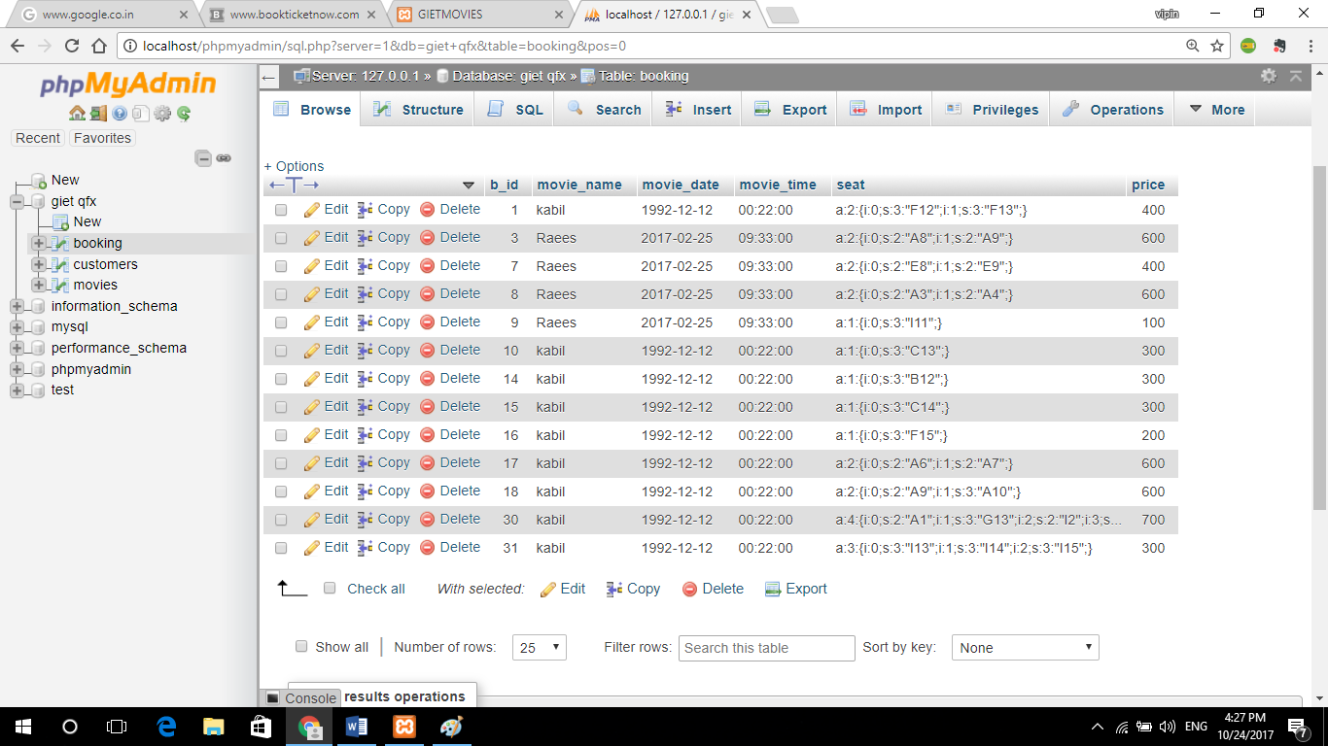

Fig: Booking Details Table

1. **Customers**

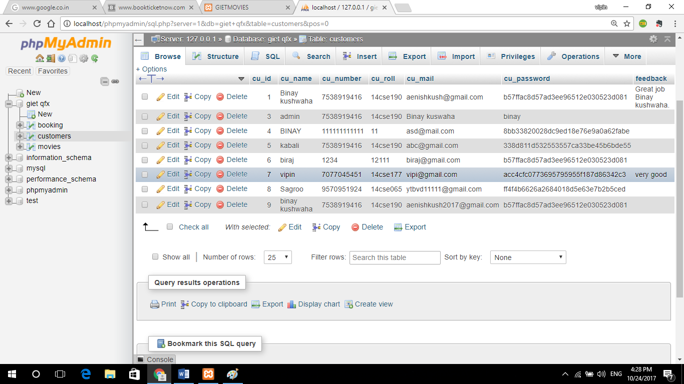

Fig: Customers Detail table

1. **Movies**

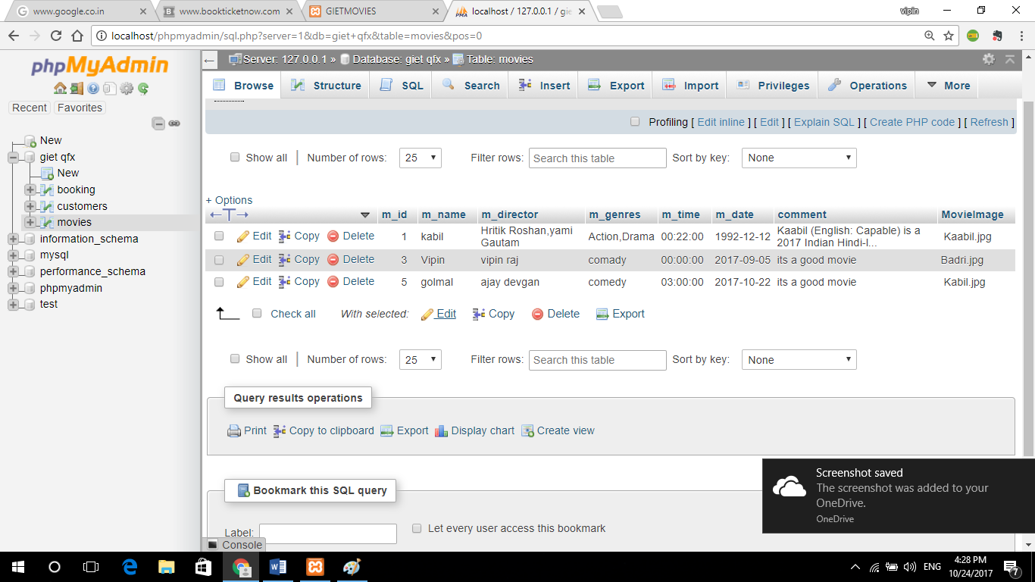

Fig: Movie Details Table

**___________________________**

**DIAGRAMS**

**___________________________**

**ER DIAGRAM**

**BOOKED SEATS**

B_ID (PK) INTEGER

B_MOVIE_NAME VARCHAR

B_SHOW_DATE DATE

B_SHOW_TIME TIME

B_SEAT VARCHAR

B_SEAT_PRICE NUMBER

**CUSTOMERS**

CU_ID (PK) INTEGER

CU_NAME CHARACTER

CU_NUMBER NUMBER

CU_ROLL VARCHAR

CU_EMAIL VARCHAR

C-_PASSWORD VARCHAR

FEEDBACK VARCHAR

**MOVIES**

M_ID (PK) INTEGER

M_NAME CHARACTER

M_DIRECTOR CHARACTER

M_GENRES CHARACTER

M_TIME TIME

M_DATE DATE

M_SUMMARY VARCHAR

M_BANNER_IMAGE VARCHAR

**USER CASE DIAGRAM**

ADMIN CUSTOMER

*FIG : USER CASE DIAGRAM*

Fig : User Case Diagram

**___________________________**

**FORM DESIGN**

**___________________________**

**FORM DESIGN**

* **Login**

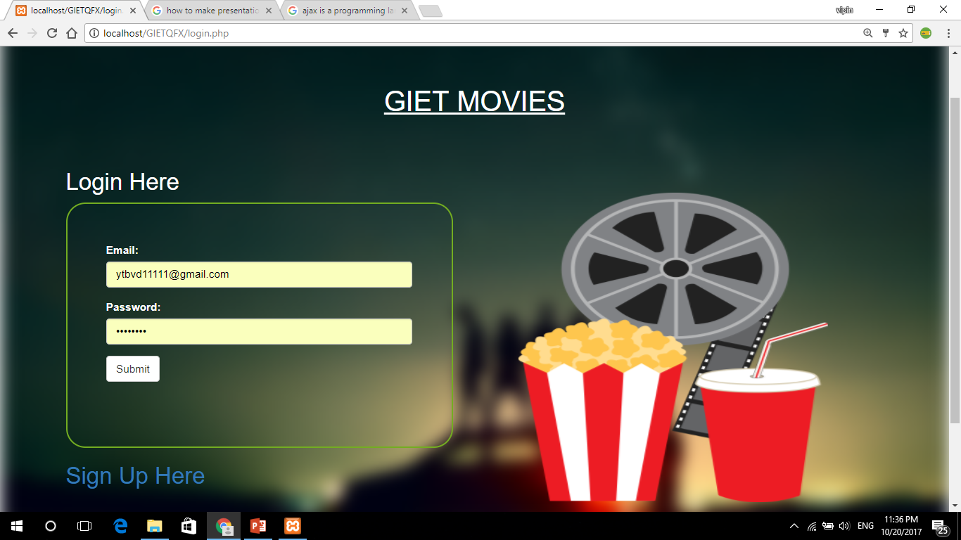

* **Register**

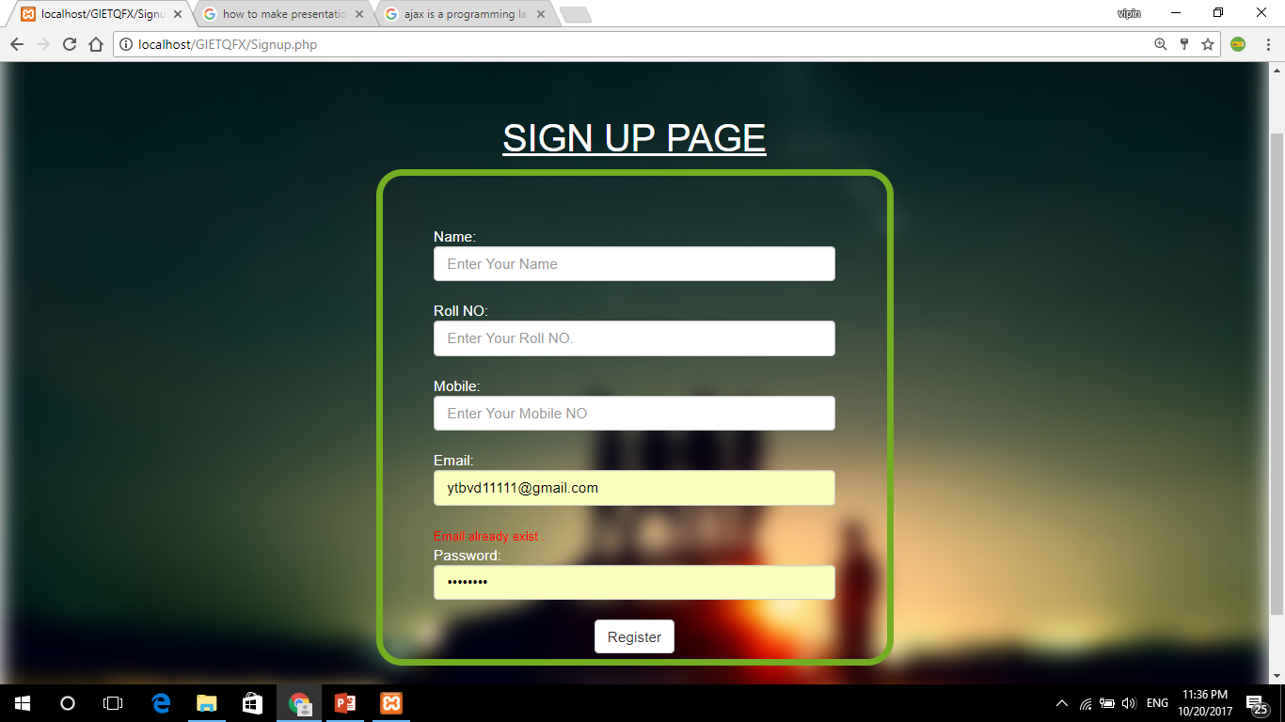

* **Homepage**

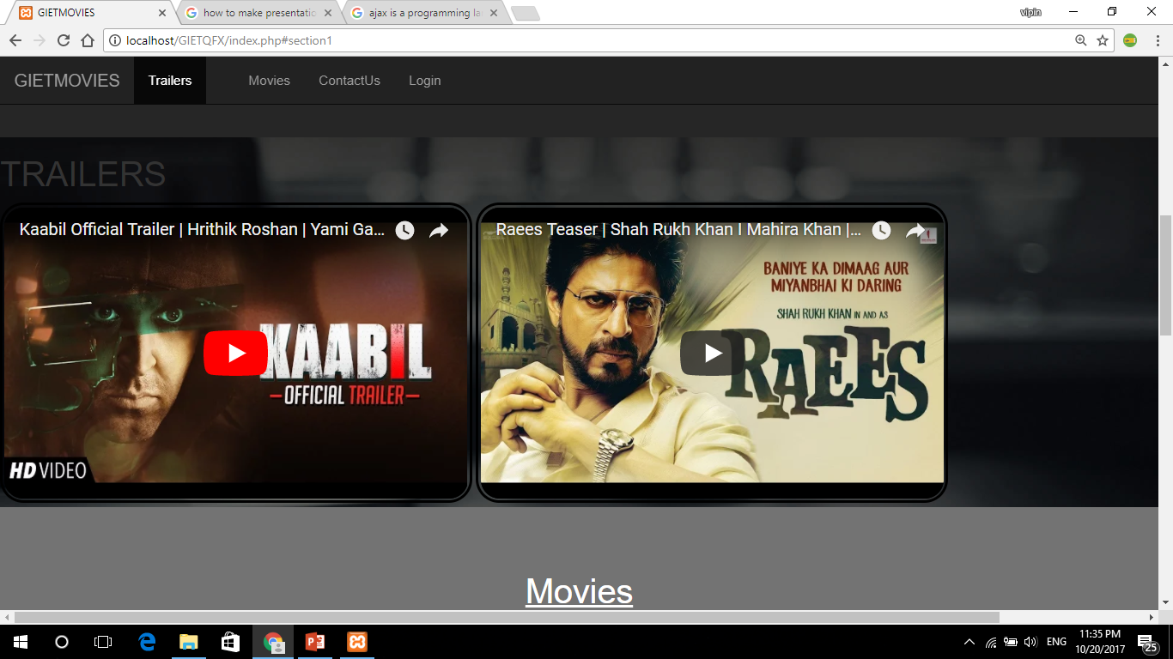

* **Booking**

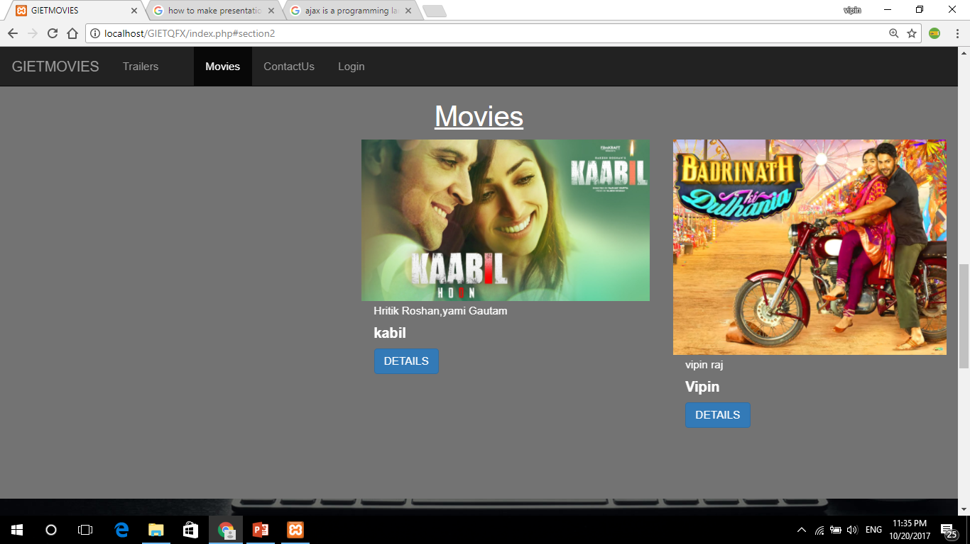

* **Movie Description**

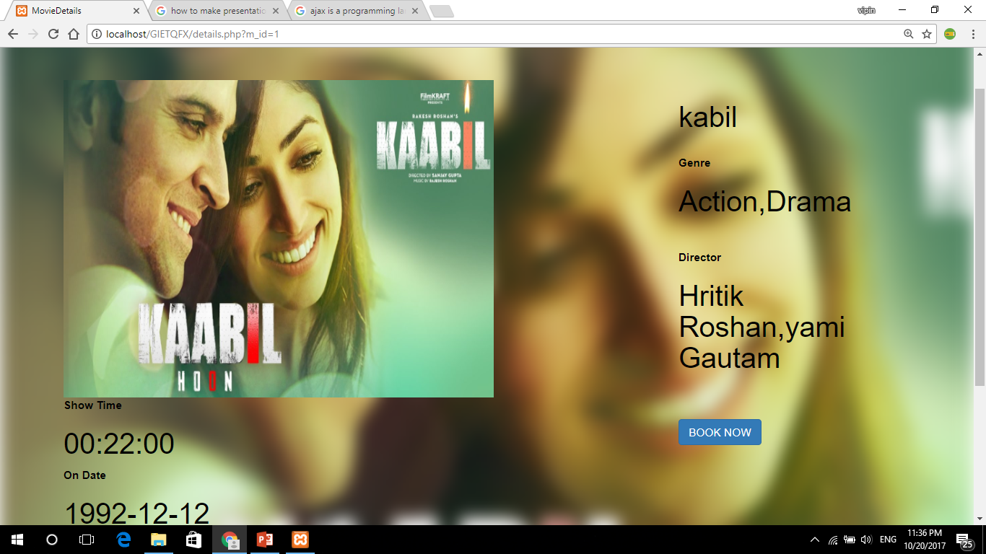

* **Feedback**

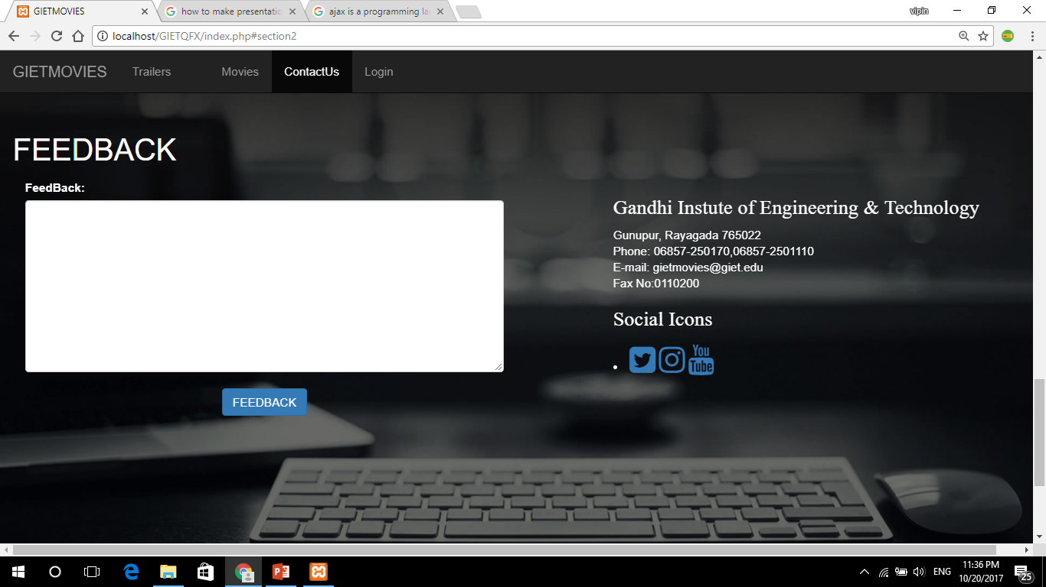

* **Poster**

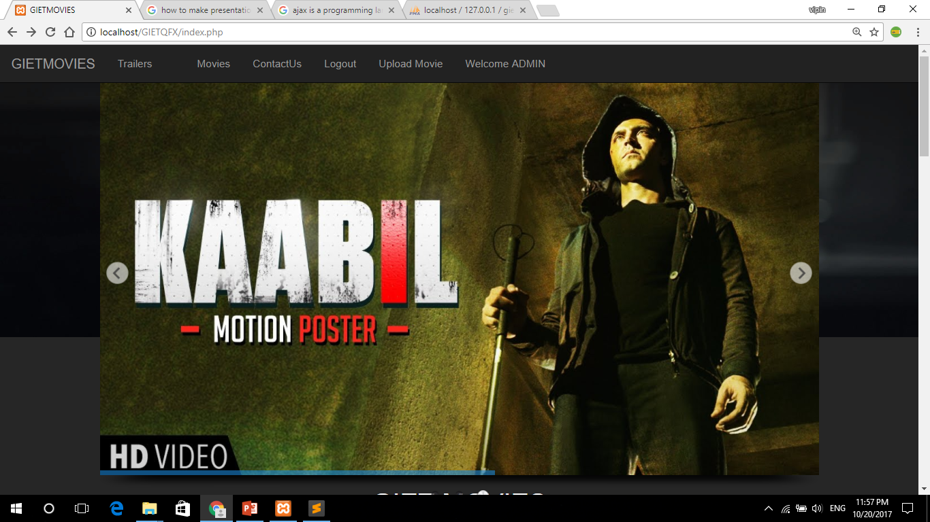

* **Seat Confirmation**

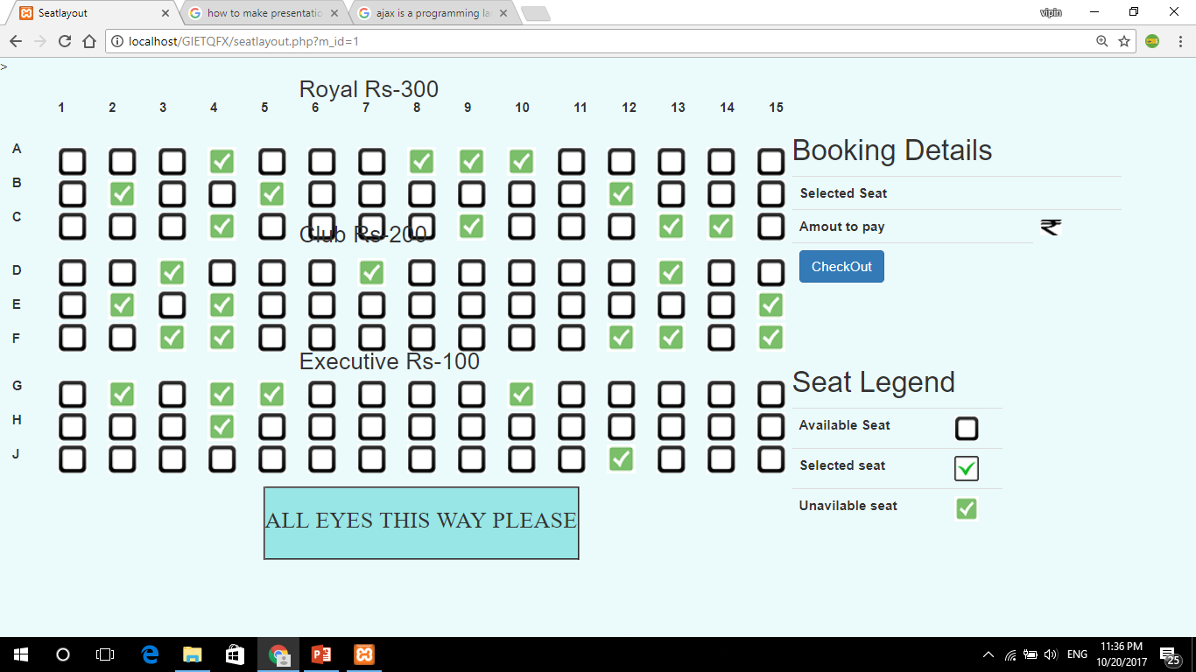

* **Admin Login**

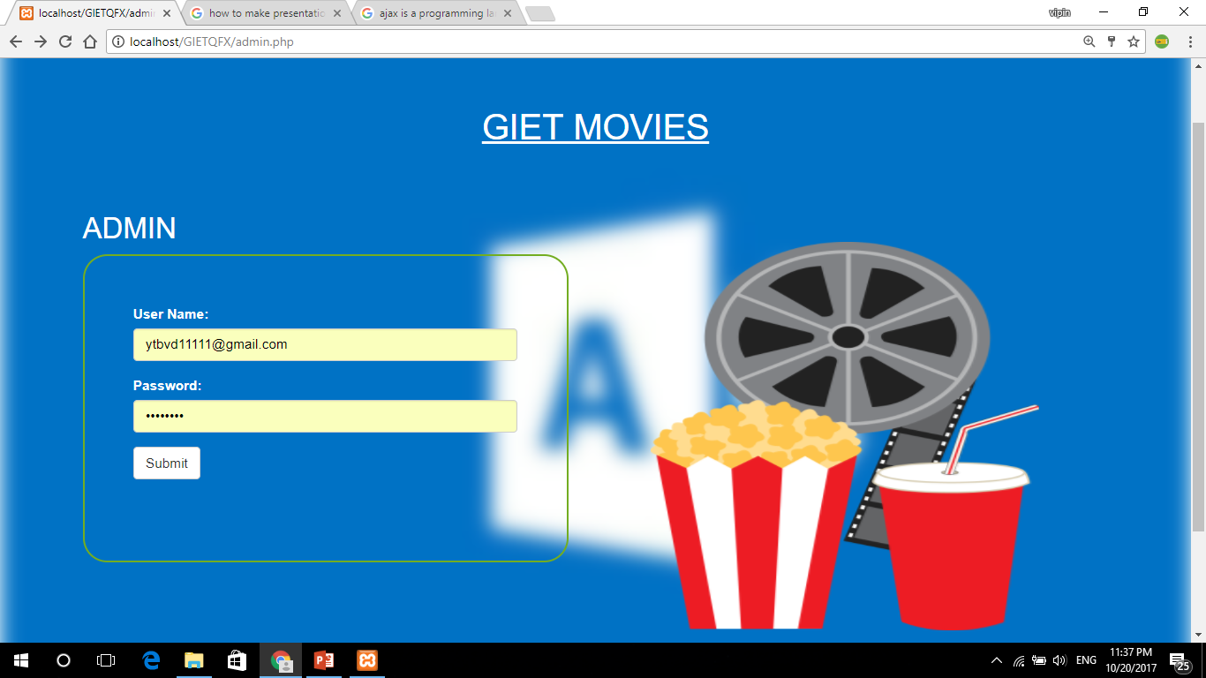

* **Movie Upload**

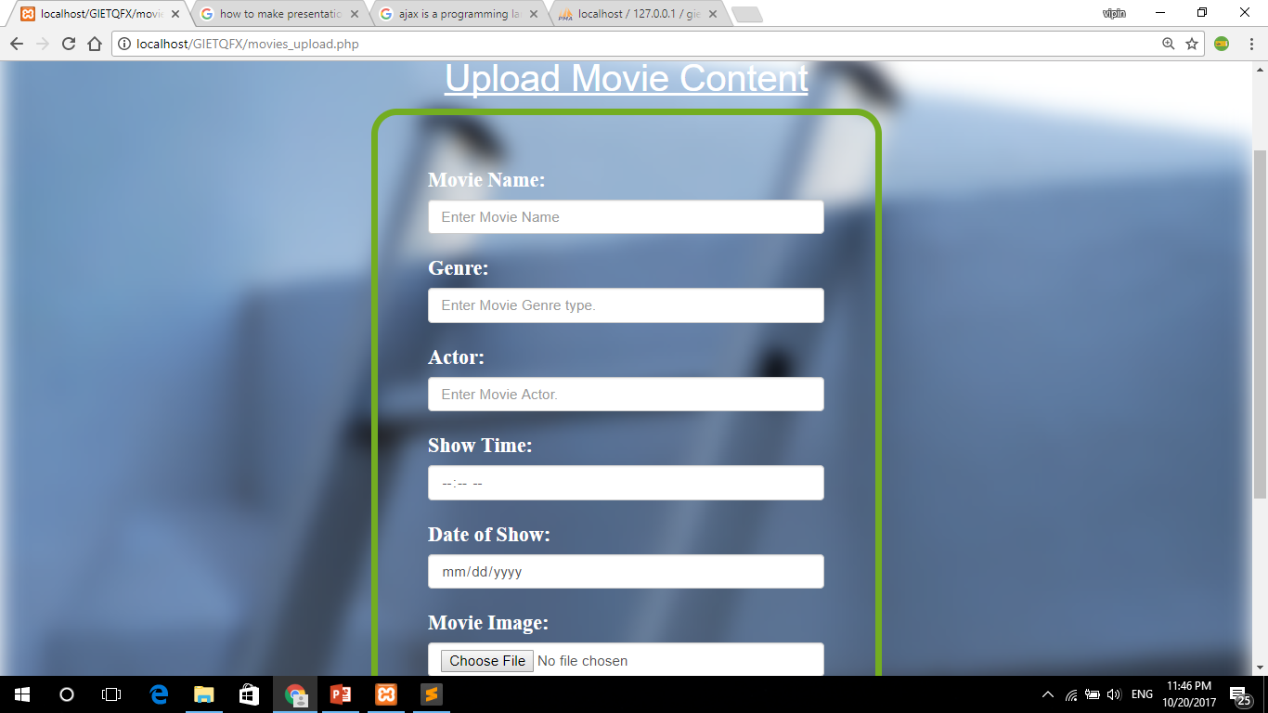

**___________________________**

**FORM CODING**

**___________________________**

**FORM CODING**

* **Login.php**

<?php session_start() ?>

<!DOCTYPE html>

<html>

<head>

<meta name="viewport" content="width=device-width, initial-scale=1">

<link rel="stylesheet" href="https://maxcdn.bootstrapcdn.com/bootstrap/3.3.7/css/bootstrap.min.css">

<script src="https://ajax.googleapis.com/ajax/libs/jquery/3.1.1/jquery.min.js"></script>

<script src="https://maxcdn.bootstrapcdn.com/bootstrap/3.3.7/js/bootstrap.min.js"></script>

<style>

.backgroundImageCVR{

position:relative;

padding:85px;

}

.background-image{

position:absolute;

left:0;

right:0;

top:0;

bottom:0;

background:url('Powe.jpg');

background-size:cover ;

z-index:1;

-webkit-filter: blur(10px);

-moz-filter: blur(20px);

-o-filter: blur(20px);

-ms-filter: blur(20px);

filter: blur(10px);

}

.content{

position:relative;

z-index:2;

color:#fff;

}

.columns {

-webkit-columns: 150px 3; /* Chrome, Safari, Opera */

-moz-columns: 200px 3; /* Firefox */

columns: 300px 2;

}

#corners {

border-radius: 25px;

border: 2px solid #73AD21;

padding: 50px;

width: 500px;

height: 318px;

}

#corners2 {

border-radius: 25px;

border: 0px solid #73AD21;

padding: 50px;

width: 500px;

height: 500px;

}

</style>

</head>

<body>

<a href="index.php"><Strong>Home</Strong></a>

<div class="backgroundImageCVR">

<div class="background-image" ></div>

<div class="content" >

<u>

<h1 align="center">GIET MOVIES</h1>

</u>

</br></br>

<div class="columns" >

<h2>Login Here</h2>

<form action="login_process.php" onsubmit="return validateForm()" name="cu_reg" method="post" id="corners" >

<div class="col-xs-15" >

<div class="form-group" id="frm">

<label for="email">Email:</label>

<input type="email" class="form-control" name="email" placeholder="Enter email">

</div>

<div class="form-group">

<label for="pwd">Password:</label>

<input type="password" class="form-control" name="password" placeholder="Enter password">

</div>

<button type="submit" name="submit" class="btn btn-default">Submit</button>

</div>

</form>

<a href="Signup.php"><h2>Sign Up Here</h2></a>

</br></br>

<img src="mov.png" height="40%" width="40%" id="corners2">

</div>

</div>

</div>

</div>

</div>

<script type="text/javascript">

function validateForm() {

var V1 = document.forms["cu_reg"]["email"].value;

if (V1 == "") {

alert("Enter Email.");

return false;

}

var V2 = document.forms["cu_reg"]["password"].value;

if (V2 == "") {

alert("Enter Password.");

return false;

}

}

</script>

</body>

</html>

**___________________________**

**CONCLUSION**

**___________________________**

**CONCLUSION**

The project entitled **Online Movie Ticket Booking** was completed successfully.

The system has been developed with much care and free of errors and at the same time it is efficient and less time consuming. The purpose of this project was to develop a web application for booking movie tickets from a theatre.

This project helped us in gaining valuable information and practical knowledge on several topics like designing web pages using html & css, usage of responsive templates, , and management of database using mysql . The entire system is secured. Also the project helped us understanding about the development phases of a project and software development life cycle. We learned how to test different features of a project.

This project has given us great satisfaction in having designed an application which can be implemented to any nearby theatres running various kinds of movies by simple modifications.

**___________________________**

**BIBLOGRAPHY**

**___________________________**

**REFERENCES**

JavaScript Enlightenment,Cody Lindley-First Edition, based on JavaScript 1.5, ECMA-262, Editio

Complete CSS Guide ,Maxine Sherrin and John Allsopp-O'Reilly

Media; September 2012

* http://www.w3schools.com/html/defualt.asp,
* http://www.w3schools.com/css/default.asp,
* <http://www.w3schools.com/js/default.asp>,
* <http://www.w3schools.com/php/default.asp>,
* http://www.w3schools.com/bootstrap/default.asp